* **OSI layers (L1–L7) vs TCP/IP stack (Link, Internet, Transport, Application)**

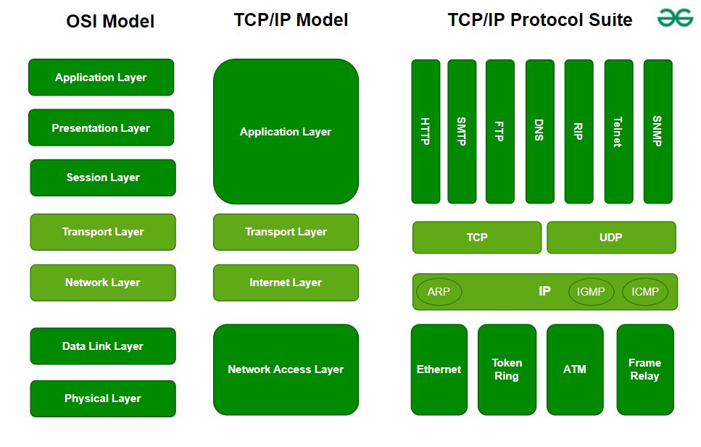

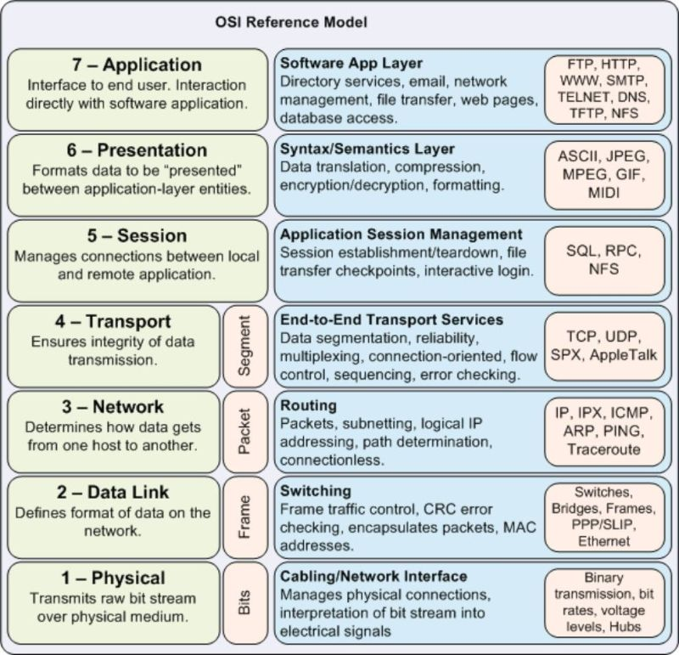

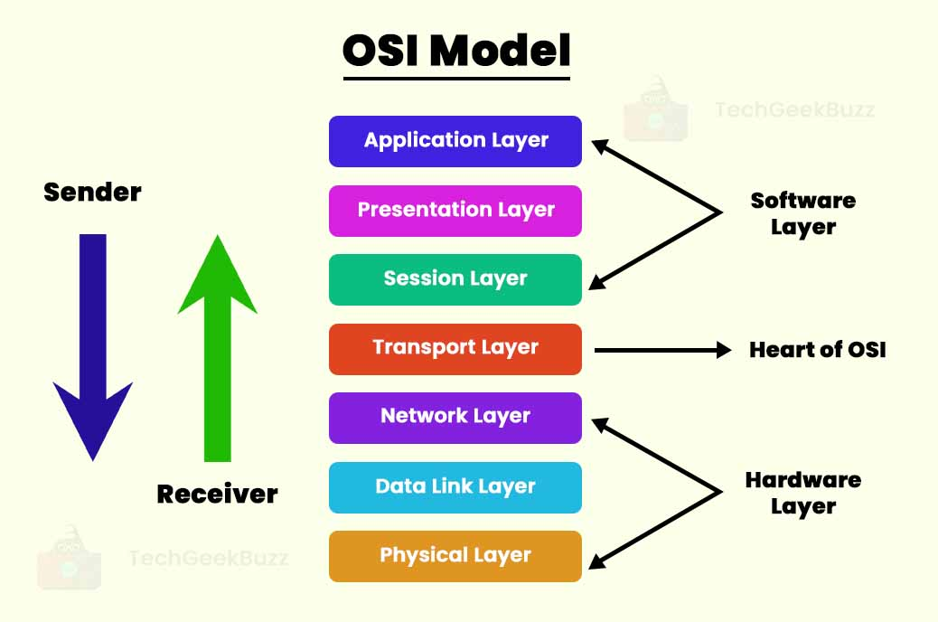

**The OSI model has seven layers (L1–L7) for conceptual understanding, while the TCP/IP stack has four layers that combine OSI functions for practical Internet communication.**

**OSI Model (L1–L7)**

The **OSI (Open Systems Interconnection) model** is a **theoretical framework** used to understand network communication. It consists of seven layers:

1. [**Physical Layer (L1)** – Transmits raw bits over physical media, such as cables or wireless signals.](https://www.bing.com/ck/a?!&&p=d19b5fa9a89209ac3c4185489d49bd681e5f34c12d8b007d828ef427c1a3b11bJmltdHM9MTc3MDUwODgwMA&ptn=3&ver=2&hsh=4&fclid=099767a3-61e7-605b-07bf-712b608b61b4&psq=OSI+layers+(L1%e2%80%93L7)+vs+TCP%2fIP+stack+(Link%2c+Internet%2c+Transport%2c+Application)&u=a1aHR0cHM6Ly93d3cuZ2Vla3Nmb3JnZWVrcy5vcmcvY29tcHV0ZXItbmV0d29ya3MvZGlmZmVyZW5jZS1iZXR3ZWVuLW9zaS1tb2RlbC1hbmQtdGNwLWlwLW1vZGVsLw&ntb=1)
2. [**Data Link Layer (L2)** – Provides reliable node-to-node data transfer and error detection using frames.](https://www.bing.com/ck/a?!&&p=d19b5fa9a89209ac3c4185489d49bd681e5f34c12d8b007d828ef427c1a3b11bJmltdHM9MTc3MDUwODgwMA&ptn=3&ver=2&hsh=4&fclid=099767a3-61e7-605b-07bf-712b608b61b4&psq=OSI+layers+(L1%e2%80%93L7)+vs+TCP%2fIP+stack+(Link%2c+Internet%2c+Transport%2c+Application)&u=a1aHR0cHM6Ly93d3cuZ2Vla3Nmb3JnZWVrcy5vcmcvY29tcHV0ZXItbmV0d29ya3MvZGlmZmVyZW5jZS1iZXR3ZWVuLW9zaS1tb2RlbC1hbmQtdGNwLWlwLW1vZGVsLw&ntb=1)
3. [**Network Layer (L3)** – Handles logical addressing and routing of packets across networks.](https://www.bing.com/ck/a?!&&p=d19b5fa9a89209ac3c4185489d49bd681e5f34c12d8b007d828ef427c1a3b11bJmltdHM9MTc3MDUwODgwMA&ptn=3&ver=2&hsh=4&fclid=099767a3-61e7-605b-07bf-712b608b61b4&psq=OSI+layers+(L1%e2%80%93L7)+vs+TCP%2fIP+stack+(Link%2c+Internet%2c+Transport%2c+Application)&u=a1aHR0cHM6Ly93d3cuZ2Vla3Nmb3JnZWVrcy5vcmcvY29tcHV0ZXItbmV0d29ya3MvZGlmZmVyZW5jZS1iZXR3ZWVuLW9zaS1tb2RlbC1hbmQtdGNwLWlwLW1vZGVsLw&ntb=1)
4. [**Transport Layer (L4)** – Ensures reliable (TCP) or fast (UDP) delivery of data between hosts.](https://www.bing.com/ck/a?!&&p=d19b5fa9a89209ac3c4185489d49bd681e5f34c12d8b007d828ef427c1a3b11bJmltdHM9MTc3MDUwODgwMA&ptn=3&ver=2&hsh=4&fclid=099767a3-61e7-605b-07bf-712b608b61b4&psq=OSI+layers+(L1%e2%80%93L7)+vs+TCP%2fIP+stack+(Link%2c+Internet%2c+Transport%2c+Application)&u=a1aHR0cHM6Ly93d3cuZ2Vla3Nmb3JnZWVrcy5vcmcvY29tcHV0ZXItbmV0d29ya3MvZGlmZmVyZW5jZS1iZXR3ZWVuLW9zaS1tb2RlbC1hbmQtdGNwLWlwLW1vZGVsLw&ntb=1)
5. [**Session Layer (L5)** – Manages sessions, establishing, maintaining, and terminating connections.](https://www.bing.com/ck/a?!&&p=d19b5fa9a89209ac3c4185489d49bd681e5f34c12d8b007d828ef427c1a3b11bJmltdHM9MTc3MDUwODgwMA&ptn=3&ver=2&hsh=4&fclid=099767a3-61e7-605b-07bf-712b608b61b4&psq=OSI+layers+(L1%e2%80%93L7)+vs+TCP%2fIP+stack+(Link%2c+Internet%2c+Transport%2c+Application)&u=a1aHR0cHM6Ly93d3cuZ2Vla3Nmb3JnZWVrcy5vcmcvY29tcHV0ZXItbmV0d29ya3MvZGlmZmVyZW5jZS1iZXR3ZWVuLW9zaS1tb2RlbC1hbmQtdGNwLWlwLW1vZGVsLw&ntb=1)
6. [**Presentation Layer (L6)** – Translates, encrypts, and formats data for the application layer.](https://www.bing.com/ck/a?!&&p=d19b5fa9a89209ac3c4185489d49bd681e5f34c12d8b007d828ef427c1a3b11bJmltdHM9MTc3MDUwODgwMA&ptn=3&ver=2&hsh=4&fclid=099767a3-61e7-605b-07bf-712b608b61b4&psq=OSI+layers+(L1%e2%80%93L7)+vs+TCP%2fIP+stack+(Link%2c+Internet%2c+Transport%2c+Application)&u=a1aHR0cHM6Ly93d3cuZ2Vla3Nmb3JnZWVrcy5vcmcvY29tcHV0ZXItbmV0d29ya3MvZGlmZmVyZW5jZS1iZXR3ZWVuLW9zaS1tb2RlbC1hbmQtdGNwLWlwLW1vZGVsLw&ntb=1)
7. [**Application Layer (L7)** – Provides services directly to end-user applications, such as HTTP, FTP, or email.](https://www.bing.com/ck/a?!&&p=d19b5fa9a89209ac3c4185489d49bd681e5f34c12d8b007d828ef427c1a3b11bJmltdHM9MTc3MDUwODgwMA&ptn=3&ver=2&hsh=4&fclid=099767a3-61e7-605b-07bf-712b608b61b4&psq=OSI+layers+(L1%e2%80%93L7)+vs+TCP%2fIP+stack+(Link%2c+Internet%2c+Transport%2c+Application)&u=a1aHR0cHM6Ly93d3cuZ2Vla3Nmb3JnZWVrcy5vcmcvY29tcHV0ZXItbmV0d29ya3MvZGlmZmVyZW5jZS1iZXR3ZWVuLW9zaS1tb2RlbC1hbmQtdGNwLWlwLW1vZGVsLw&ntb=1)

[The OSI model is **protocol-independent** and primarily used for **education, troubleshooting, and designing modular protocols**.](https://www.bing.com/ck/a?!&&p=ac6e1b52e36135ba7732be1bc621dfacaef1b7d2e1832c0059082da99ea14b9dJmltdHM9MTc3MDUwODgwMA&ptn=3&ver=2&hsh=4&fclid=099767a3-61e7-605b-07bf-712b608b61b4&psq=OSI+layers+(L1%e2%80%93L7)+vs+TCP%2fIP+stack+(Link%2c+Internet%2c+Transport%2c+Application)&u=a1aHR0cHM6Ly9zc2xpbnNpZ2h0cy5jb20vb3NpLW1vZGVsLXZzLXRjcC1pcC1tb2RlbC8&ntb=1)

**TCP/IP Stack**

The **TCP/IP model** is a **practical framework** used for real-world Internet communication. It has four layers:

1. [**Link Layer (Network Access)** – Combines OSI’s Physical and Data Link layers; handles hardware addressing and media access.](https://www.bing.com/ck/a?!&&p=ac6e1b52e36135ba7732be1bc621dfacaef1b7d2e1832c0059082da99ea14b9dJmltdHM9MTc3MDUwODgwMA&ptn=3&ver=2&hsh=4&fclid=099767a3-61e7-605b-07bf-712b608b61b4&psq=OSI+layers+(L1%e2%80%93L7)+vs+TCP%2fIP+stack+(Link%2c+Internet%2c+Transport%2c+Application)&u=a1aHR0cHM6Ly9zc2xpbnNpZ2h0cy5jb20vb3NpLW1vZGVsLXZzLXRjcC1pcC1tb2RlbC8&ntb=1)
2. [**Internet Layer** – Corresponds to OSI’s Network layer; responsible for logical addressing and routing using IP.](https://www.bing.com/ck/a?!&&p=ac6e1b52e36135ba7732be1bc621dfacaef1b7d2e1832c0059082da99ea14b9dJmltdHM9MTc3MDUwODgwMA&ptn=3&ver=2&hsh=4&fclid=099767a3-61e7-605b-07bf-712b608b61b4&psq=OSI+layers+(L1%e2%80%93L7)+vs+TCP%2fIP+stack+(Link%2c+Internet%2c+Transport%2c+Application)&u=a1aHR0cHM6Ly9zc2xpbnNpZ2h0cy5jb20vb3NpLW1vZGVsLXZzLXRjcC1pcC1tb2RlbC8&ntb=1)
3. [**Transport Layer** – Maps to OSI’s Transport layer; provides end-to-end communication using TCP or UDP.](https://www.bing.com/ck/a?!&&p=ac6e1b52e36135ba7732be1bc621dfacaef1b7d2e1832c0059082da99ea14b9dJmltdHM9MTc3MDUwODgwMA&ptn=3&ver=2&hsh=4&fclid=099767a3-61e7-605b-07bf-712b608b61b4&psq=OSI+layers+(L1%e2%80%93L7)+vs+TCP%2fIP+stack+(Link%2c+Internet%2c+Transport%2c+Application)&u=a1aHR0cHM6Ly9zc2xpbnNpZ2h0cy5jb20vb3NpLW1vZGVsLXZzLXRjcC1pcC1tb2RlbC8&ntb=1)
4. [**Application Layer** – Combines OSI’s Application, Presentation, and Session layers; supports protocols like HTTP, FTP, SMTP, and DNS.](https://www.bing.com/ck/a?!&&p=ac6e1b52e36135ba7732be1bc621dfacaef1b7d2e1832c0059082da99ea14b9dJmltdHM9MTc3MDUwODgwMA&ptn=3&ver=2&hsh=4&fclid=099767a3-61e7-605b-07bf-712b608b61b4&psq=OSI+layers+(L1%e2%80%93L7)+vs+TCP%2fIP+stack+(Link%2c+Internet%2c+Transport%2c+Application)&u=a1aHR0cHM6Ly9zc2xpbnNpZ2h0cy5jb20vb3NpLW1vZGVsLXZzLXRjcC1pcC1tb2RlbC8&ntb=1)

[The TCP/IP model is **protocol-specific** and widely used in **modern networking and Internet communications**, making it more practical than OSI for implementation.](https://www.bing.com/ck/a?!&&p=ac6e1b52e36135ba7732be1bc621dfacaef1b7d2e1832c0059082da99ea14b9dJmltdHM9MTc3MDUwODgwMA&ptn=3&ver=2&hsh=4&fclid=099767a3-61e7-605b-07bf-712b608b61b4&psq=OSI+layers+(L1%e2%80%93L7)+vs+TCP%2fIP+stack+(Link%2c+Internet%2c+Transport%2c+Application)&u=a1aHR0cHM6Ly9zc2xpbnNpZ2h0cy5jb20vb3NpLW1vZGVsLXZzLXRjcC1pcC1tb2RlbC8&ntb=1)

* **One real example: “curl https://example.com = App layer over TCP over IP”**

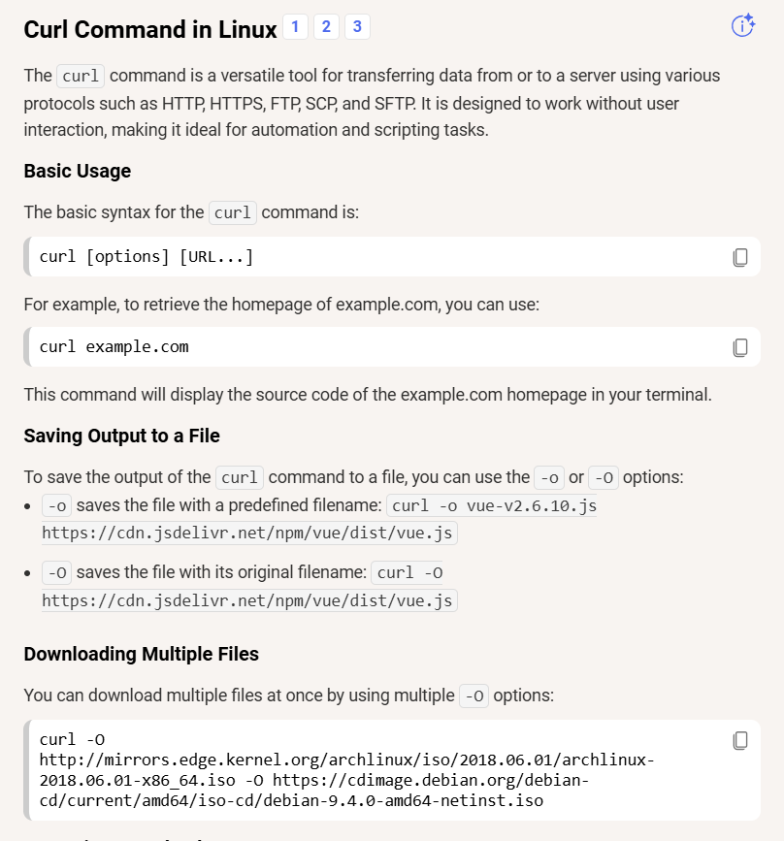

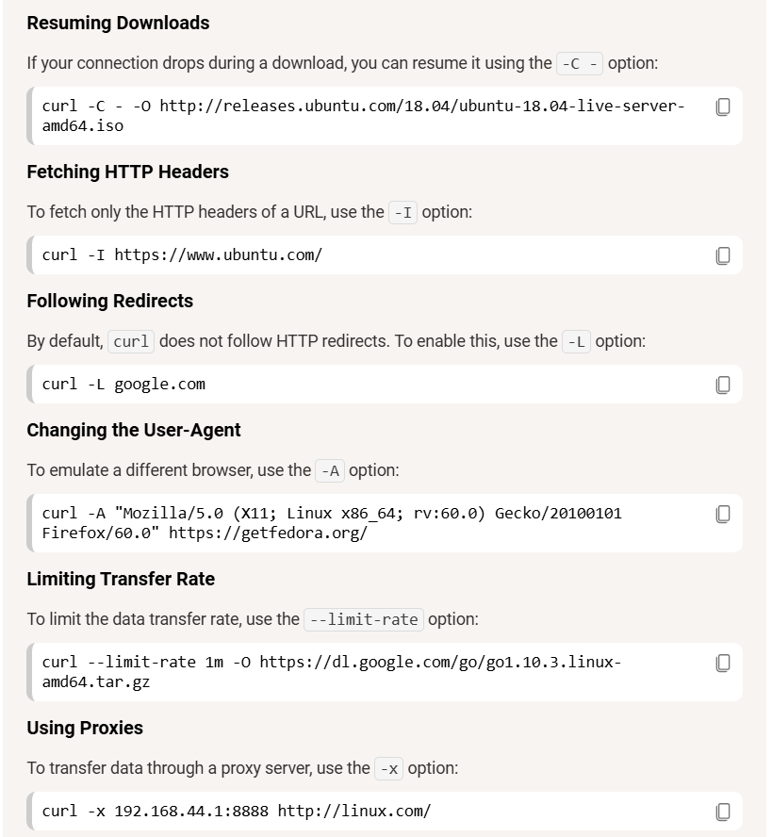

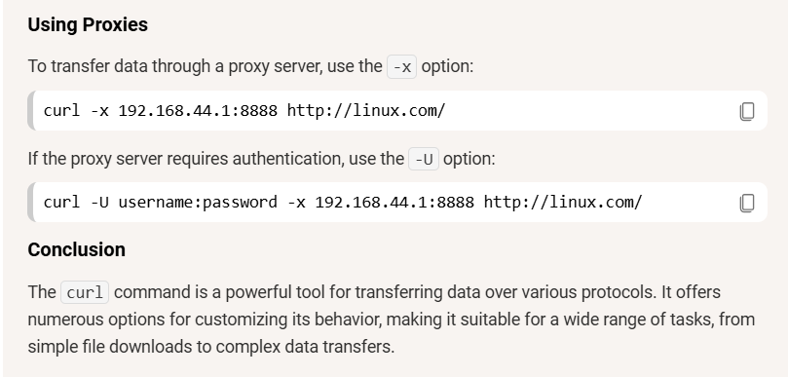

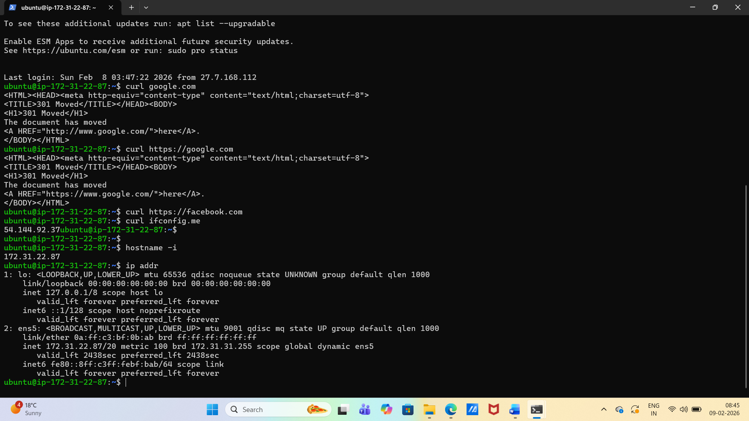

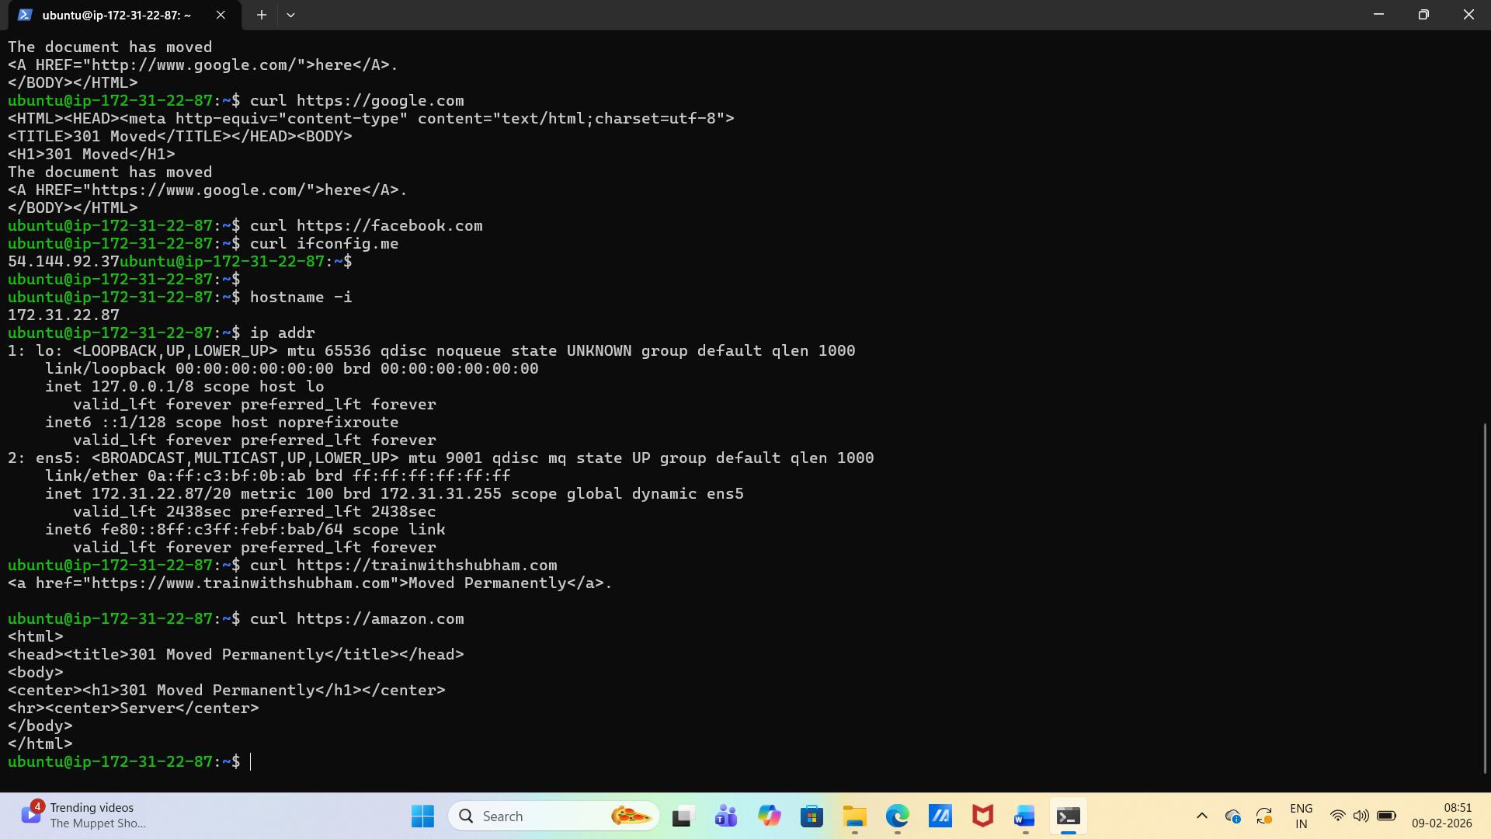

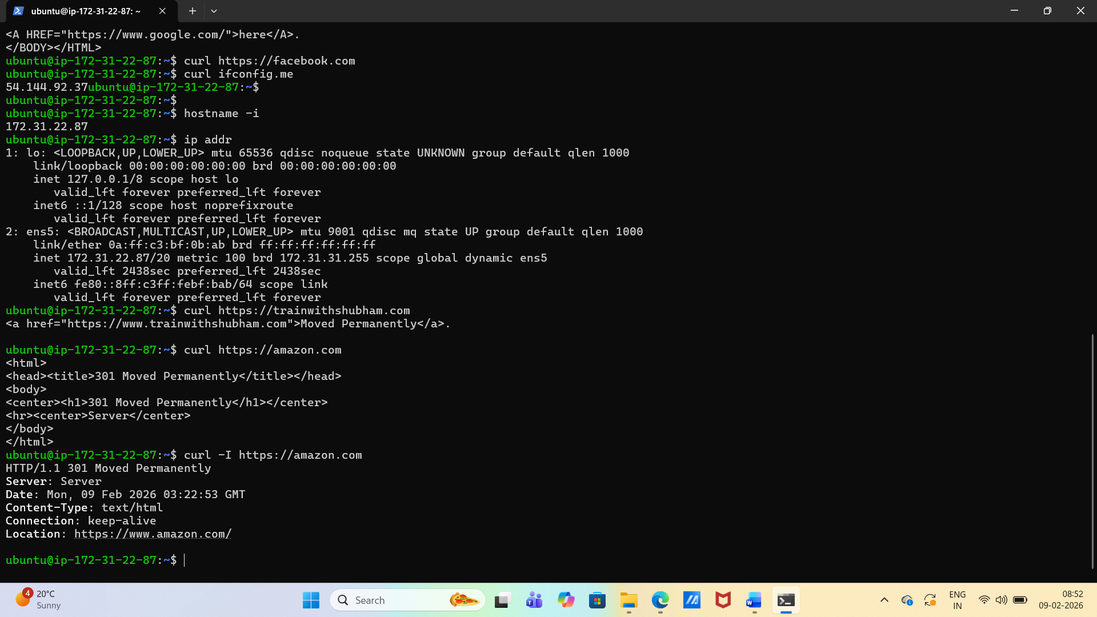

* **Identity:** hostname -I (or ip addr show) — note your IP.

hostname -I (or ip addr show) – displays private IP

Curl ifconfig.me – displays public IP

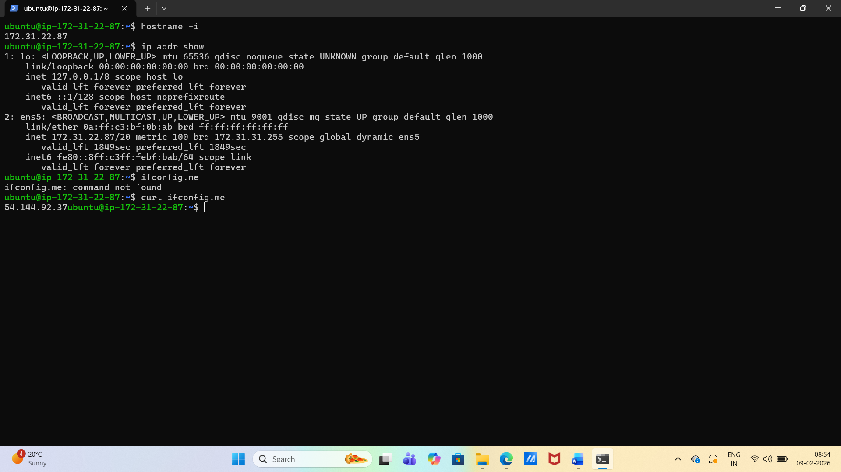

* **Reachability:** ping <target> — mention latency and packet loss.

0% Packet Loss

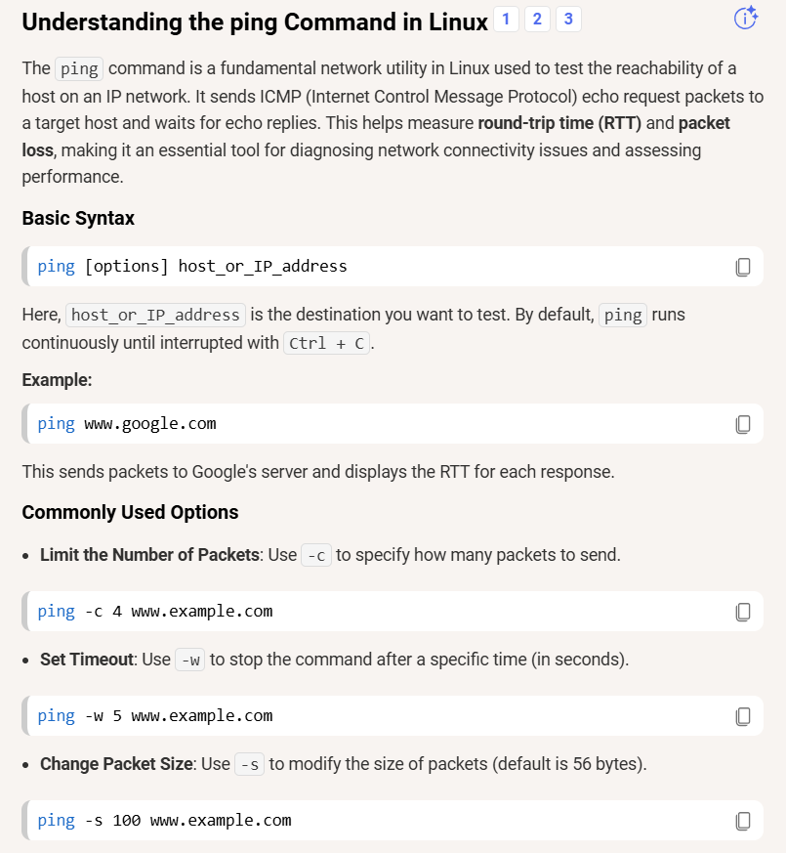

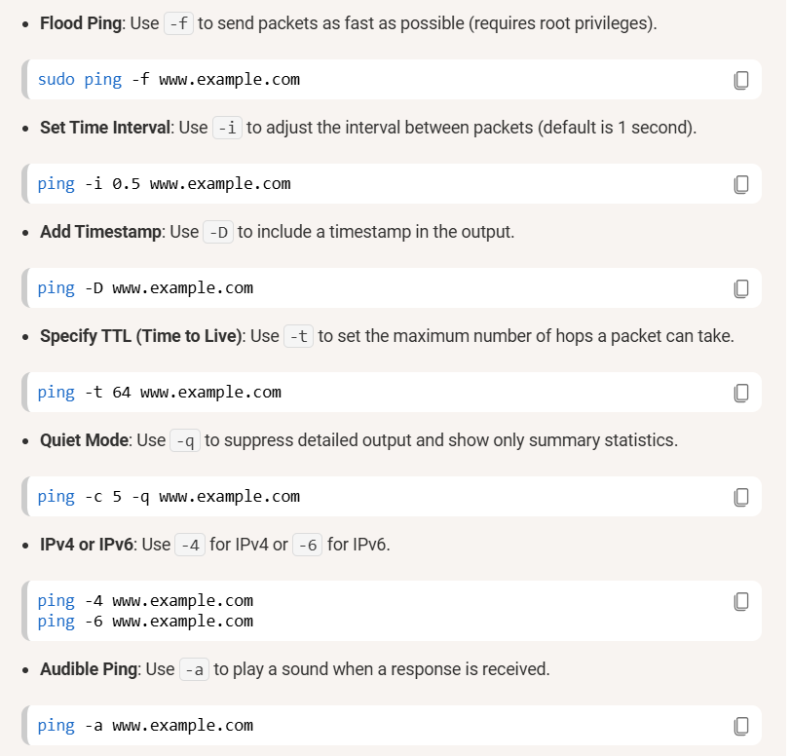

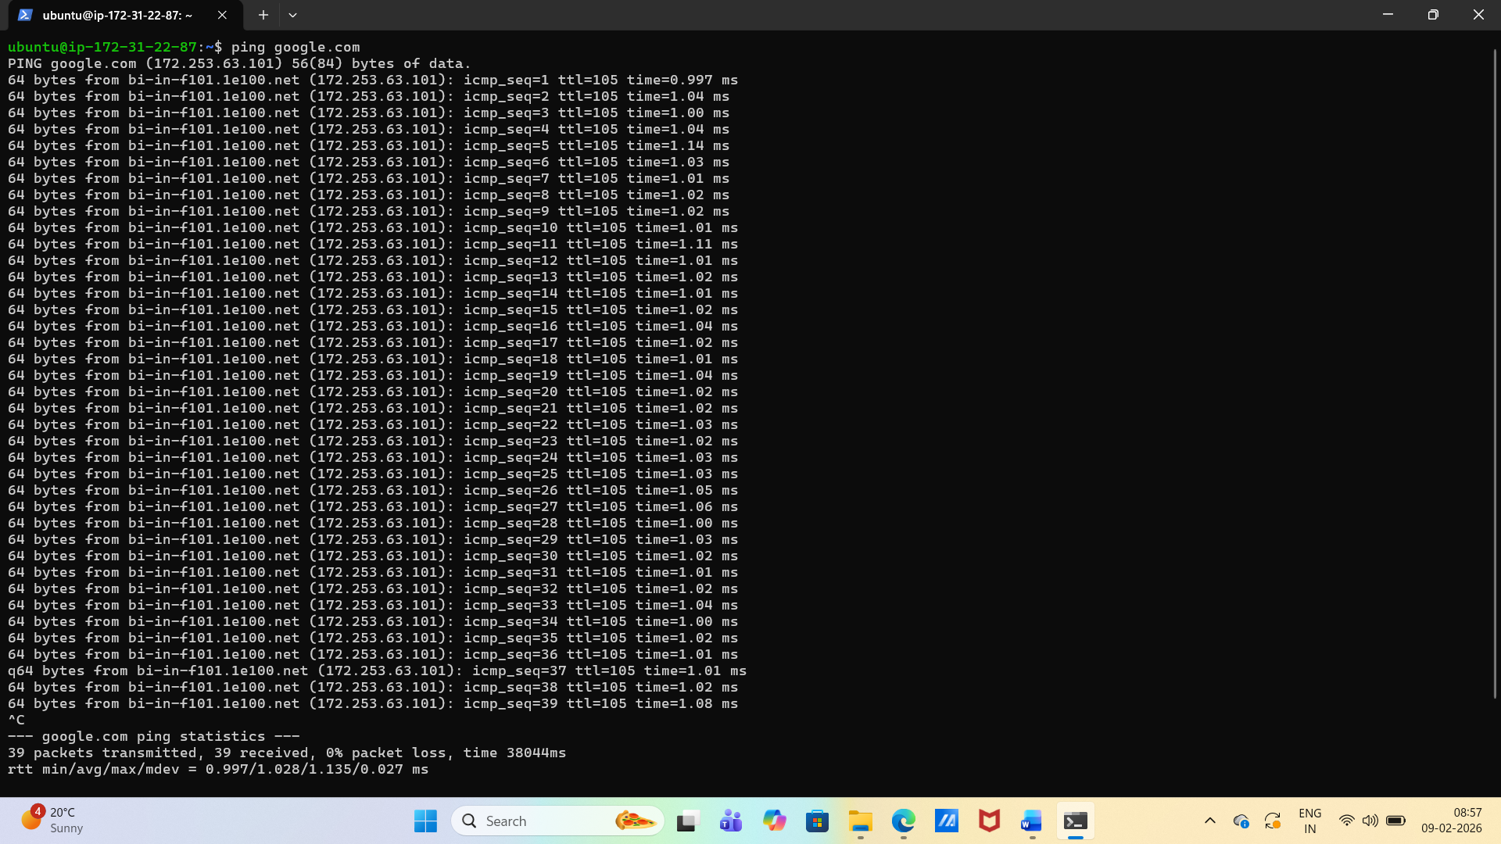

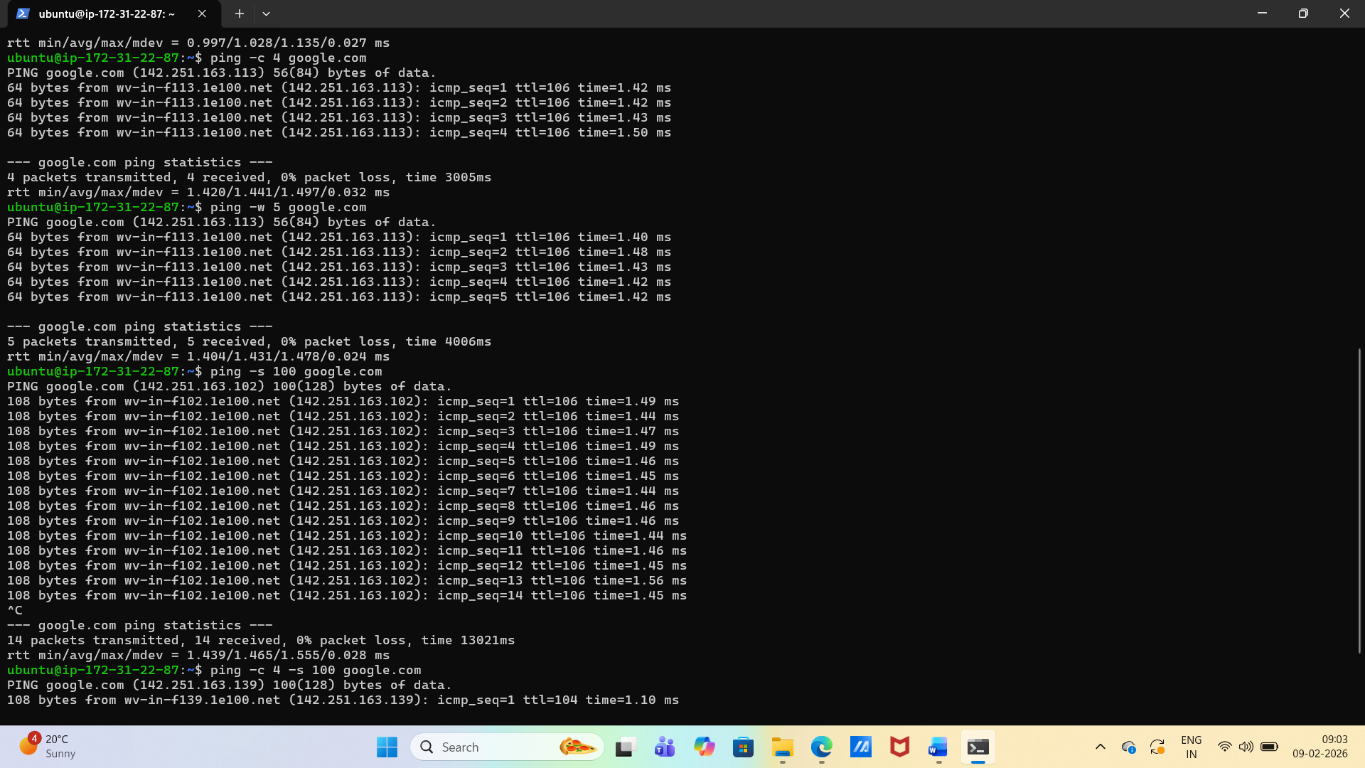

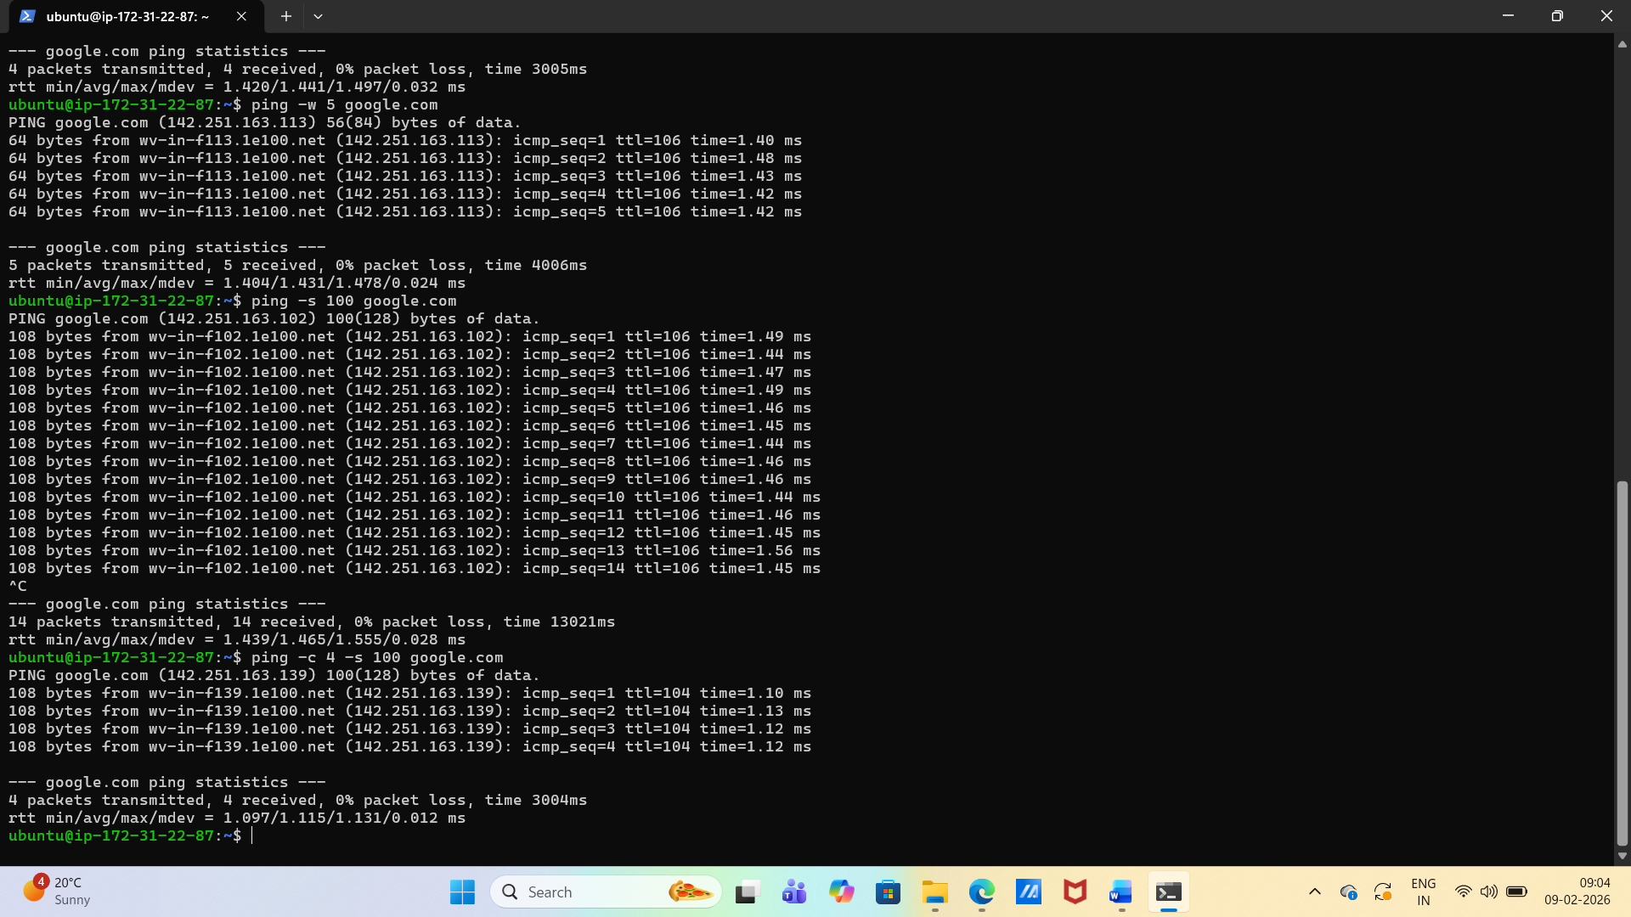

* **Path:** traceroute <target> (or tracepath) — note any long hops/timeouts.

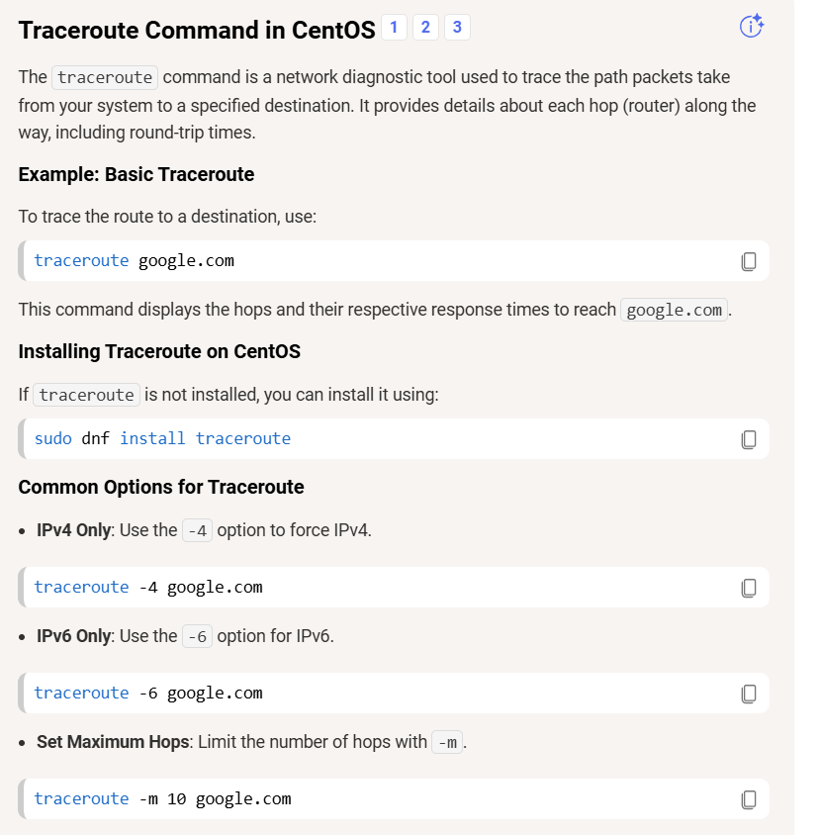

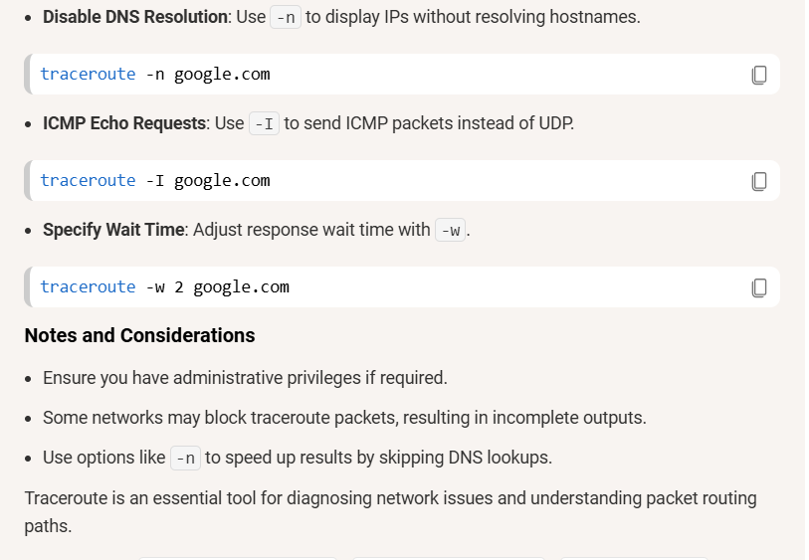

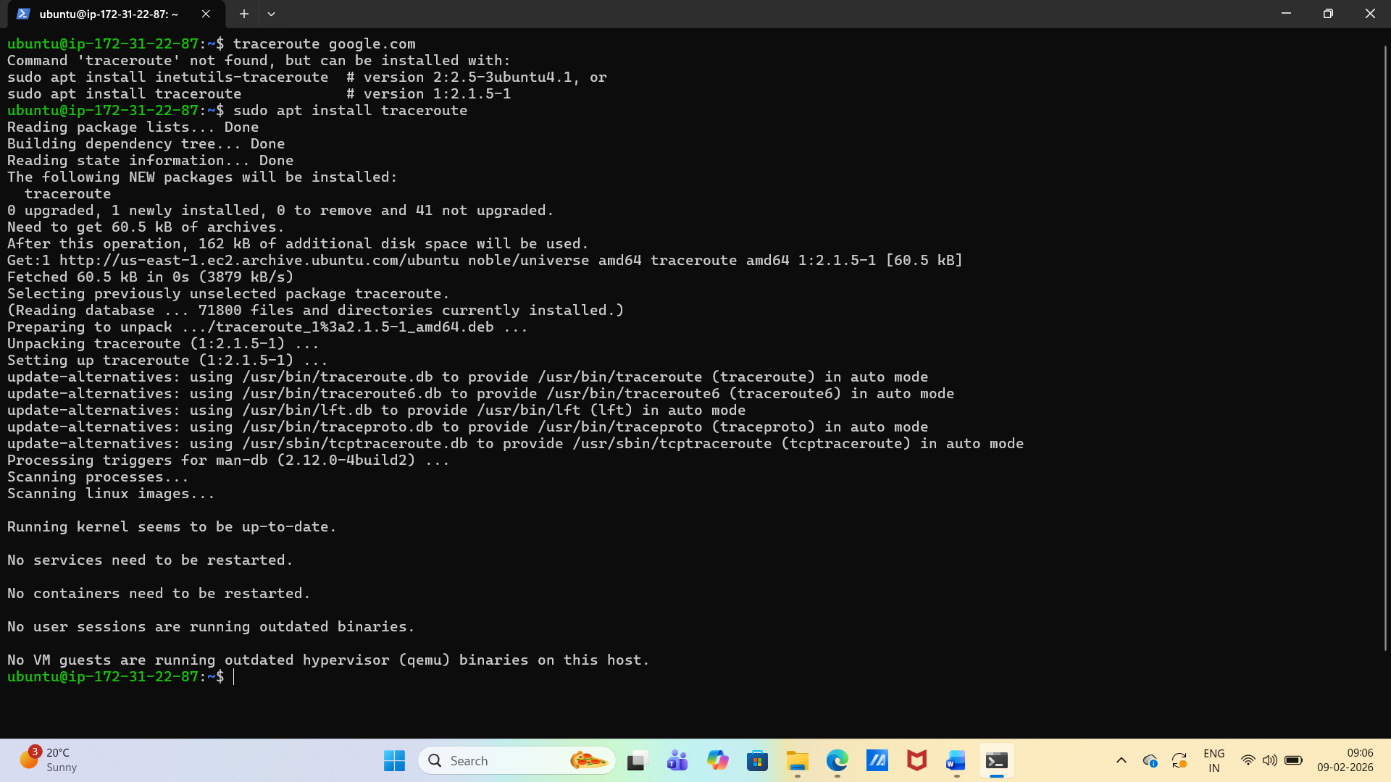

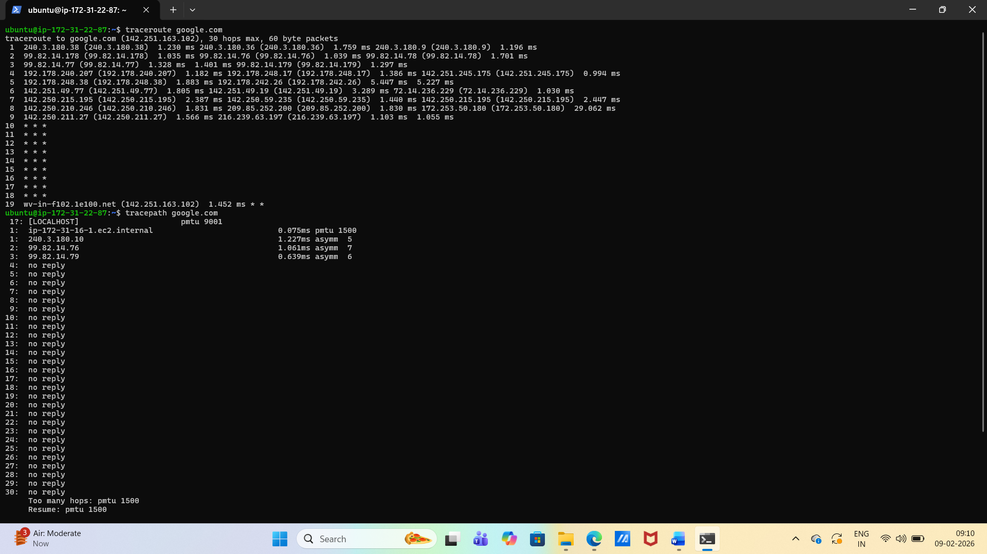

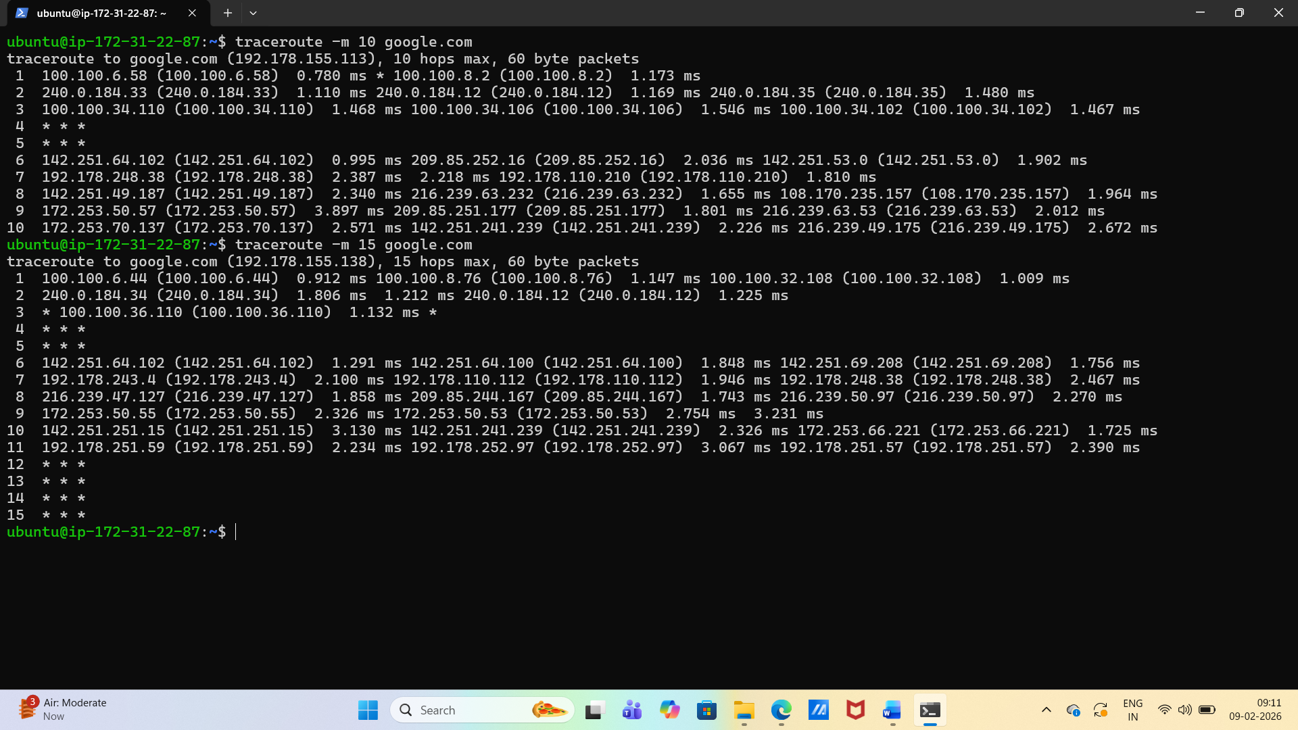

* **Ports:** ss -tulpn (or netstat -tulpn) — list one listening service and its port.

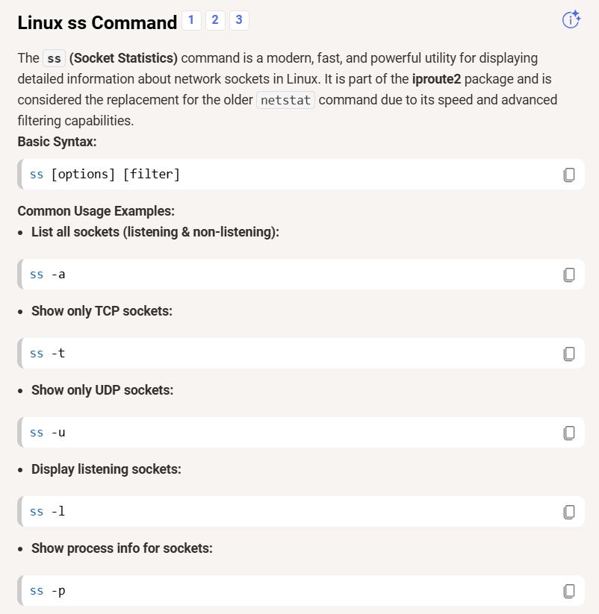

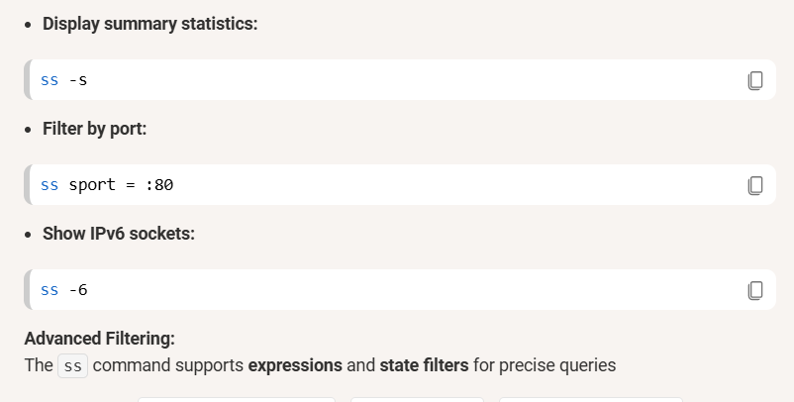

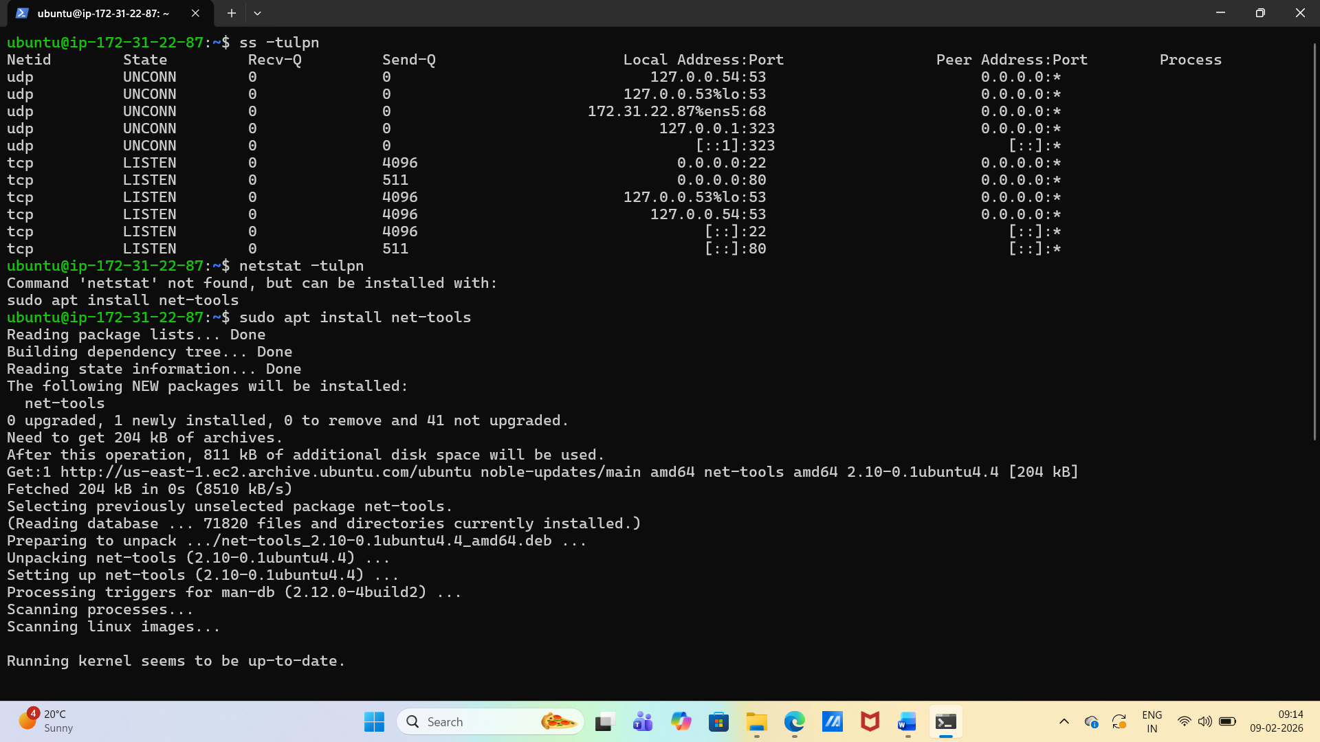

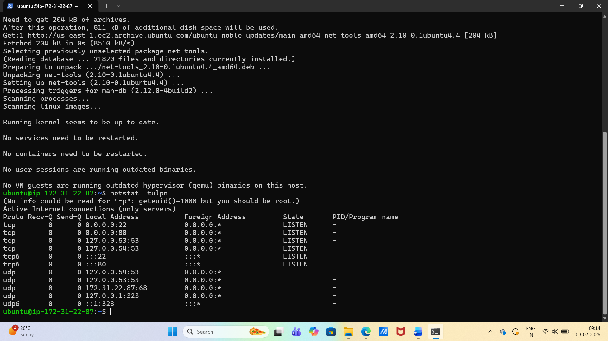

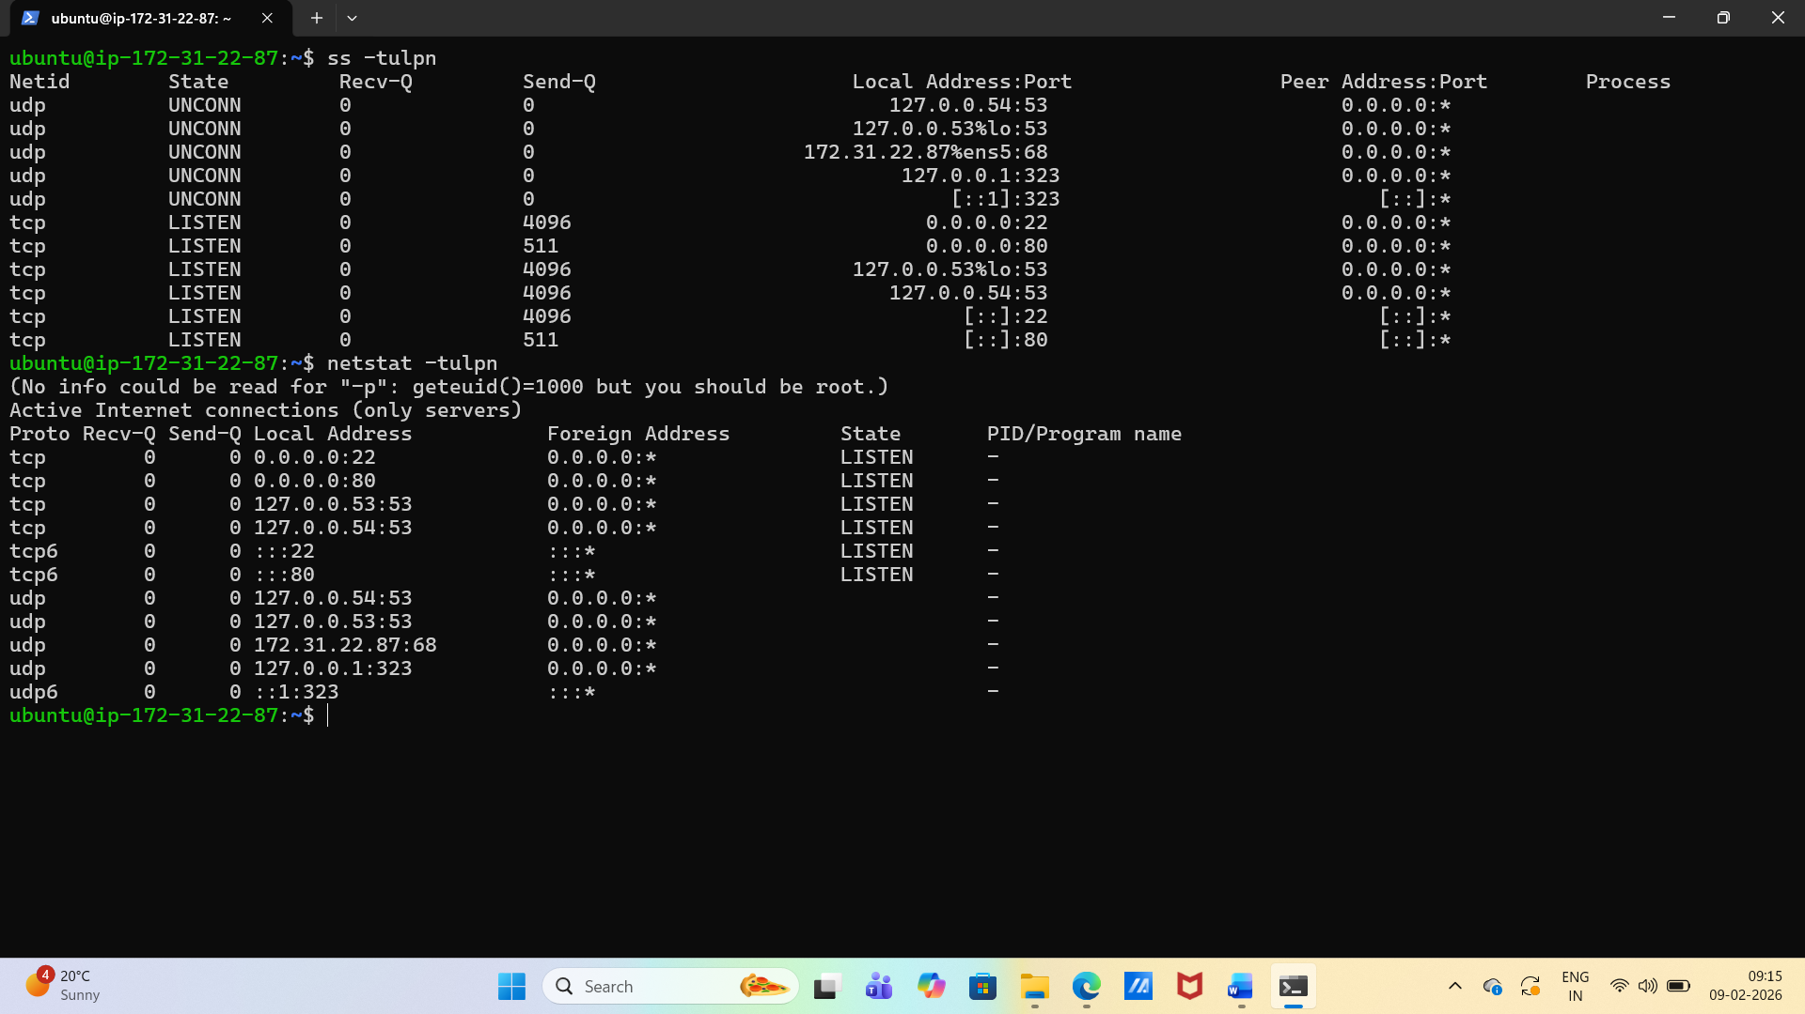

* **Name resolution:** dig <domain> or nslookup <domain> — record the resolved IP.

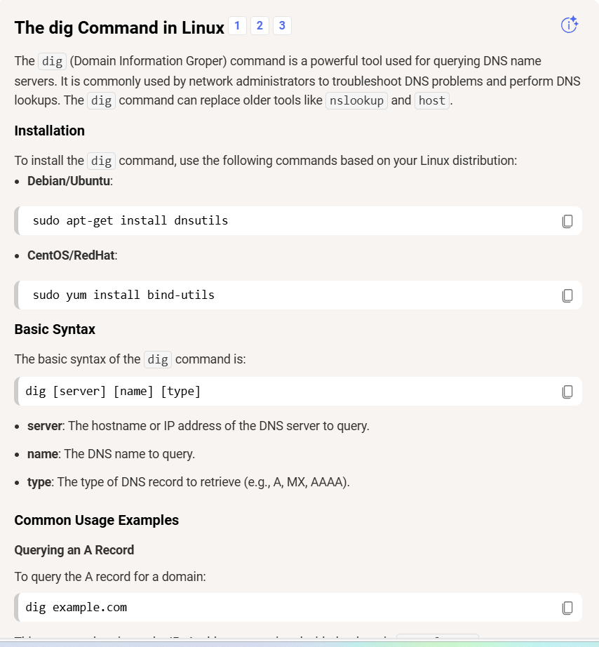

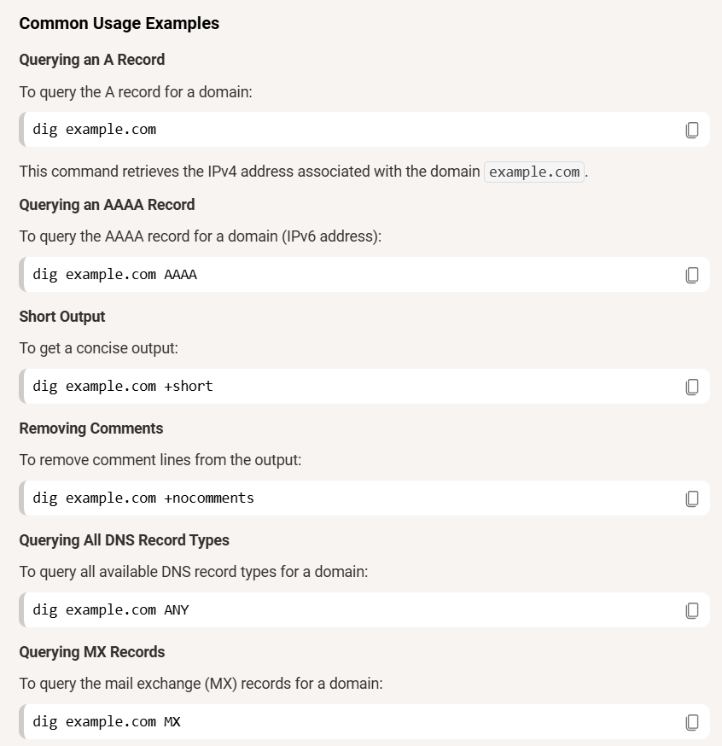

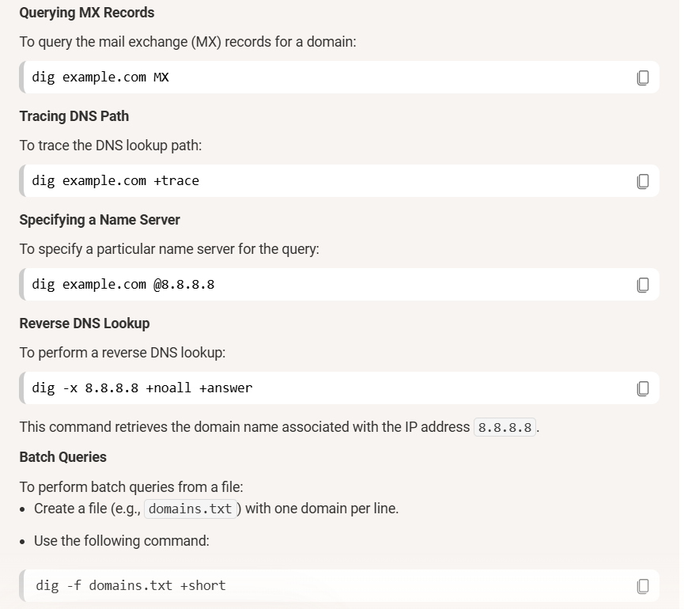

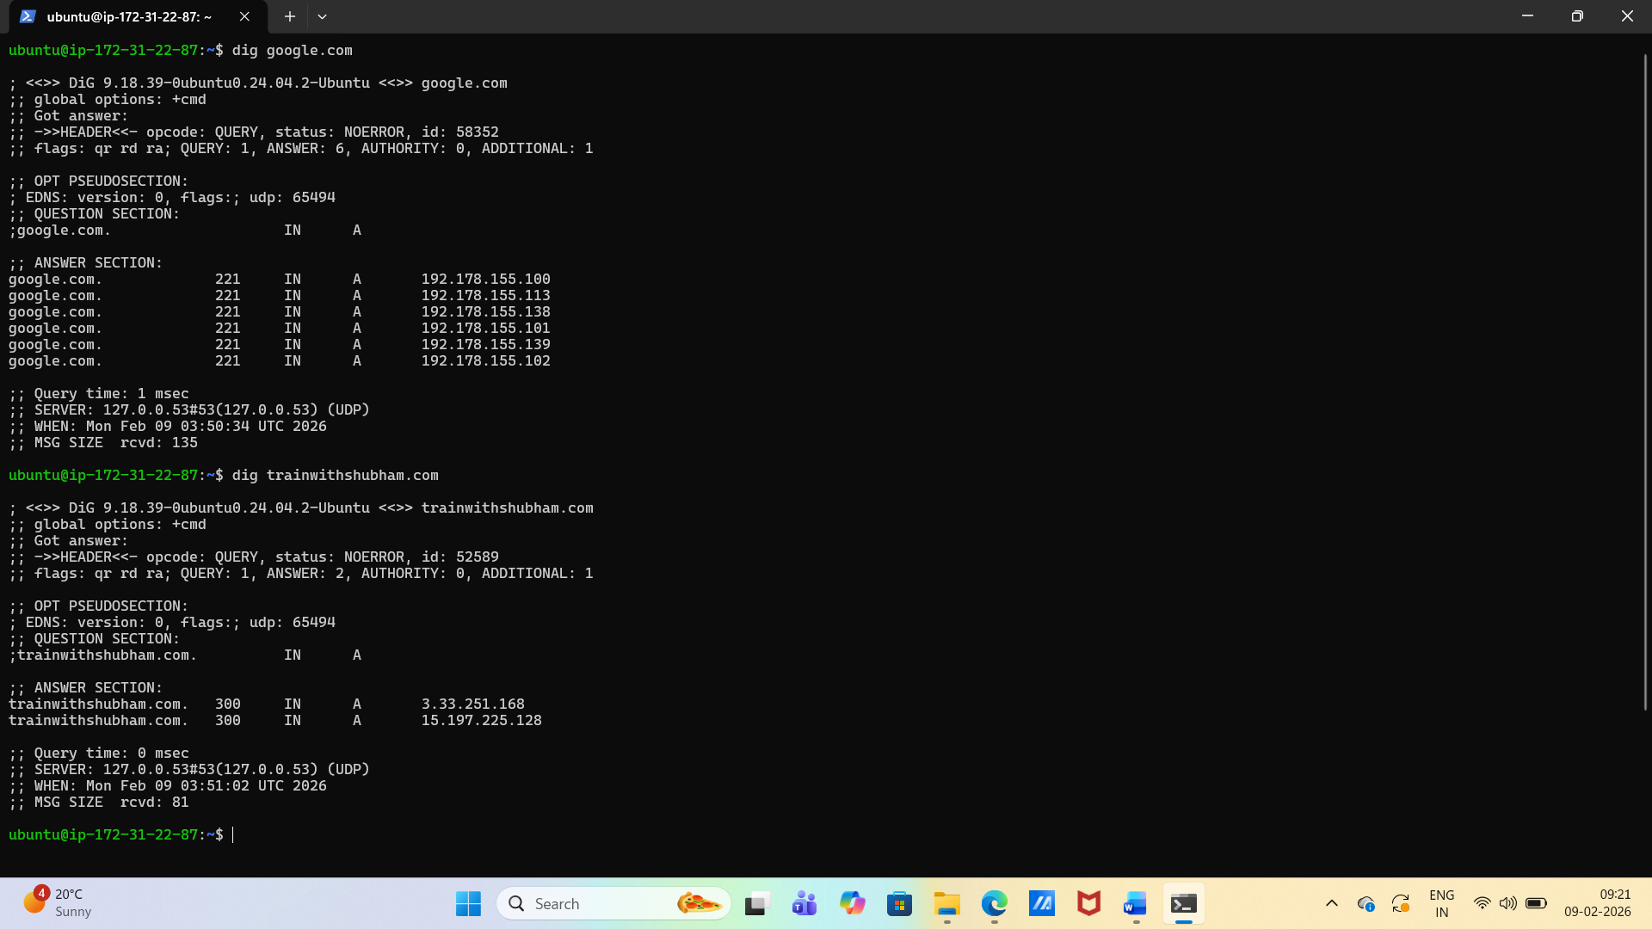

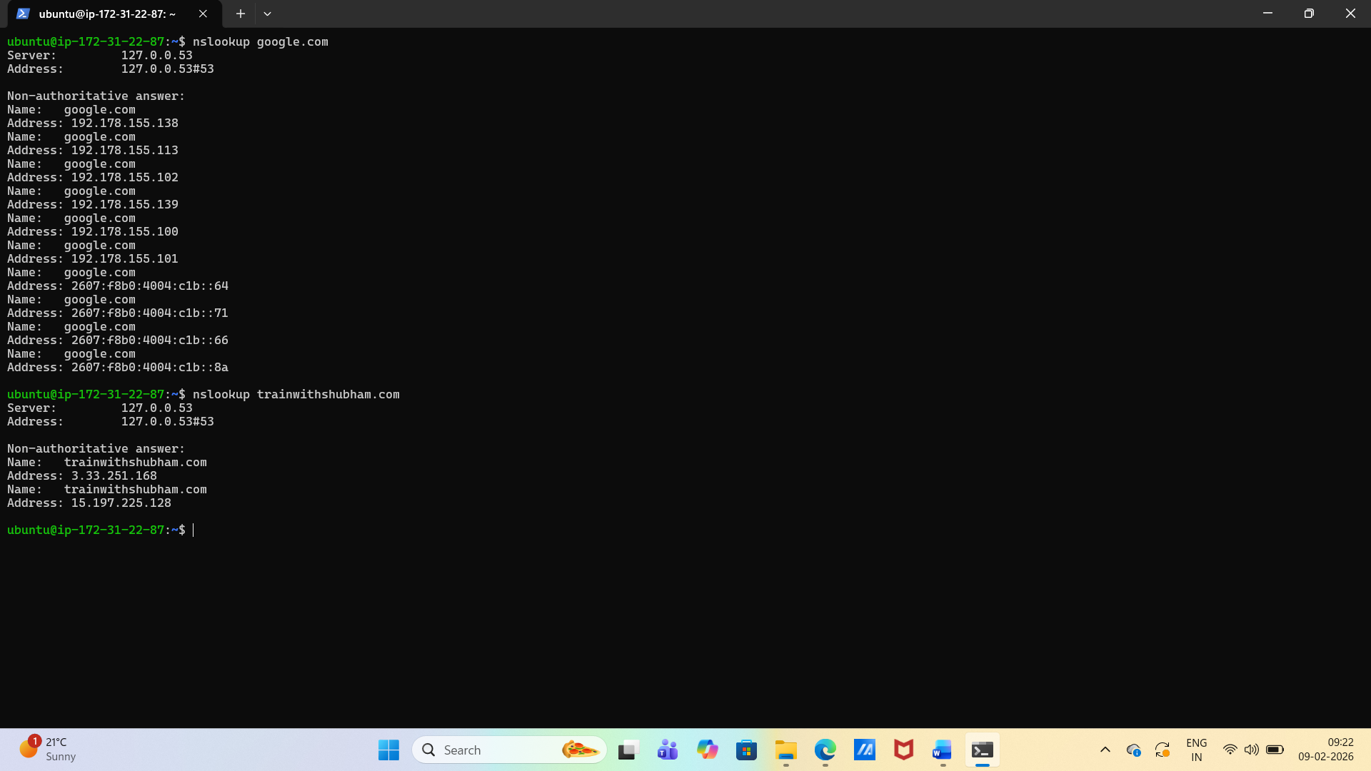

* **Connections snapshot:** netstat -an | head — count ESTABLISHED vs LISTEN (rough).

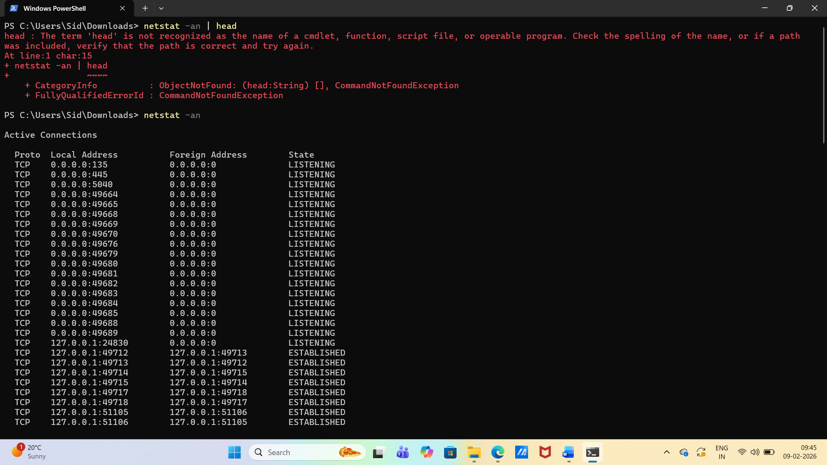

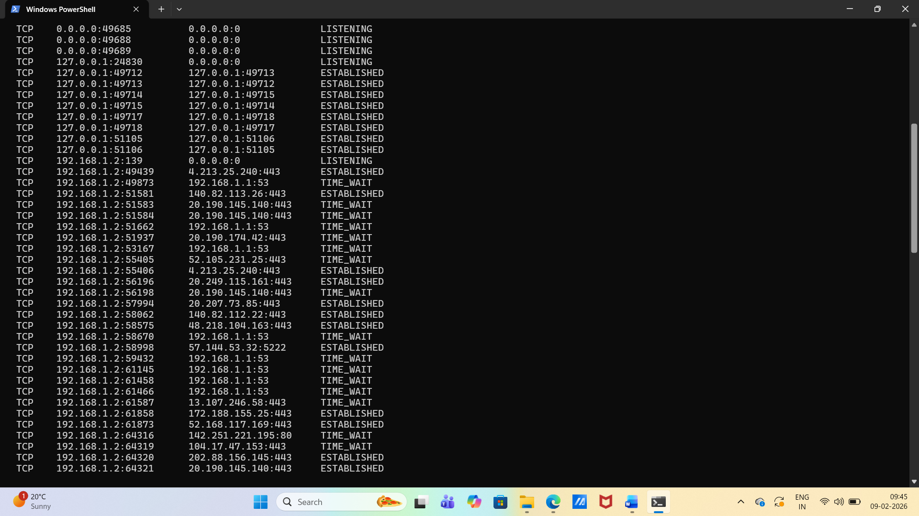

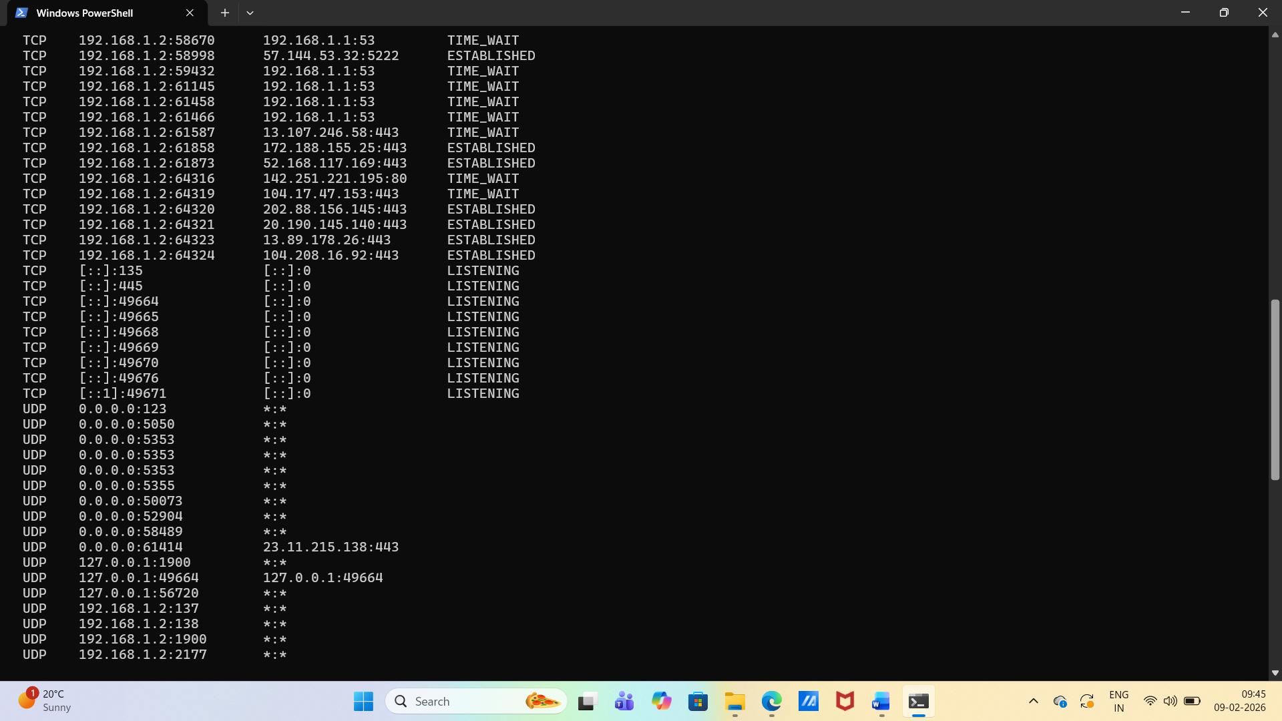

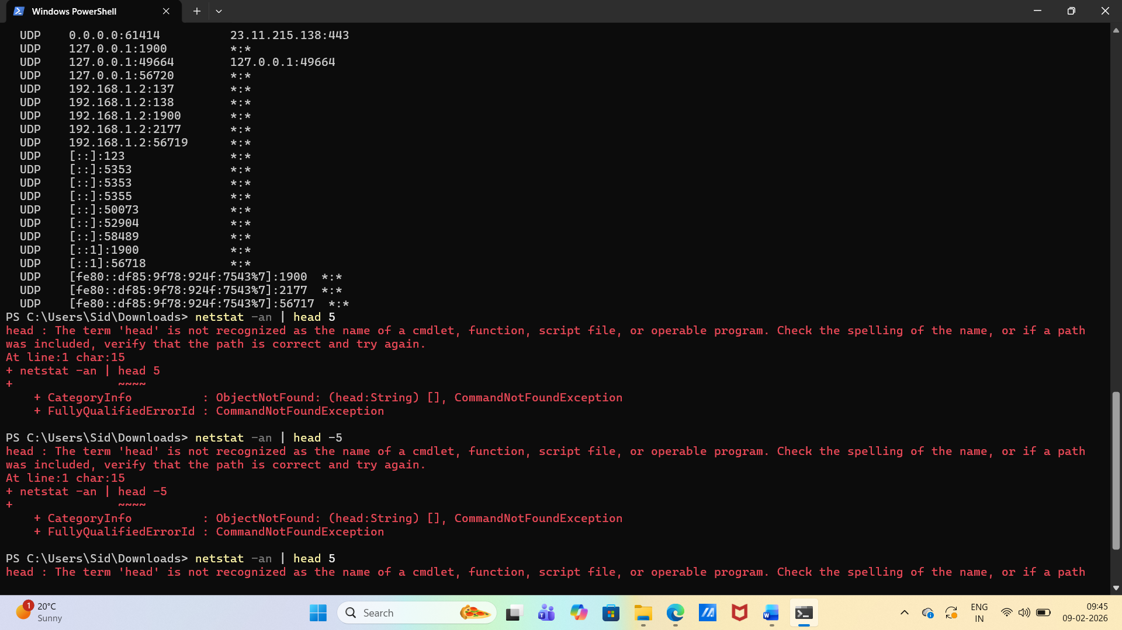

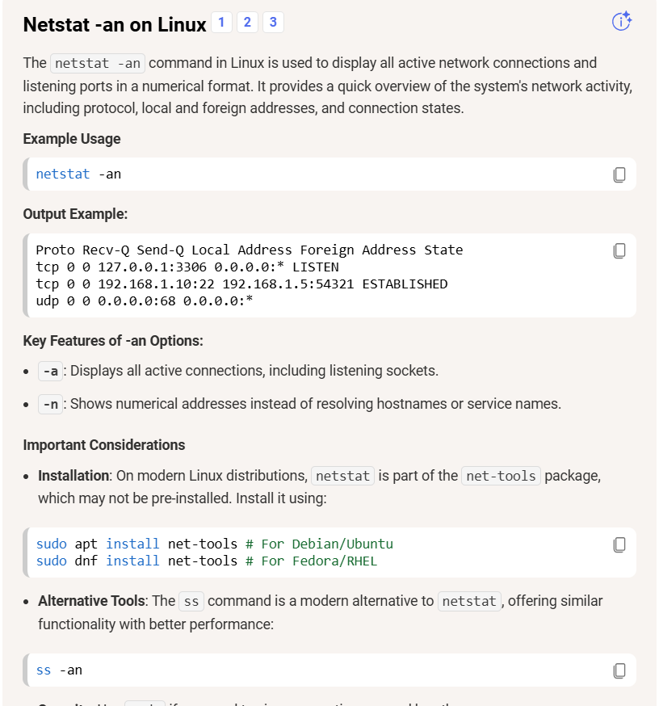

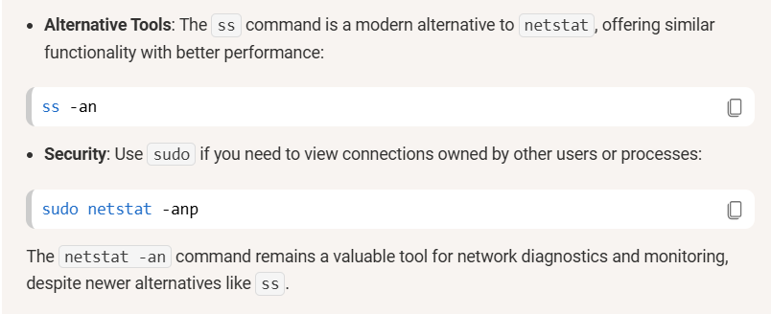

1. Identify one listening port from **ss -tulpn** (e.g., SSH on 22 or a local web app).
2. From the same machine, test it: **nc -zv localhost <port>** (or **curl -I http://localhost:<port>**).

